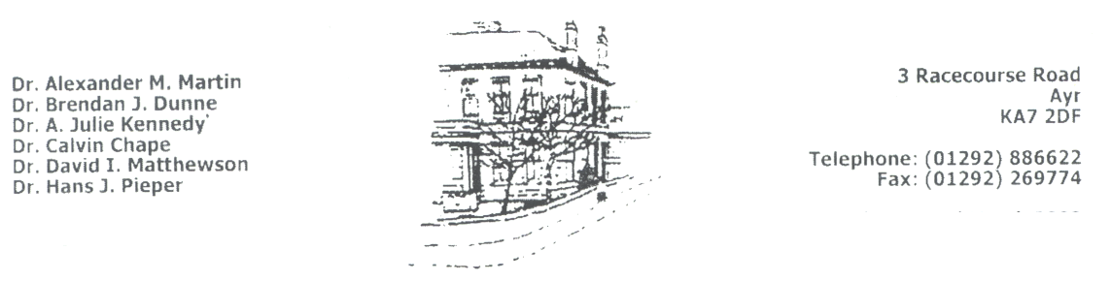

**Dr Calvin Chape (GMC 3245844) Racecourse Road Medical Group**

**Dr David I Matthewson (GMC 3493953) 3 Racecourse Road Dr Aileen Good (GMC 6128602) AYR KA7 2DF**

**Dr Peter Paton (GMC 6026511) Telephone No: 01292 Tel No: 01292 886622**

**Dr Carolyn Adams (GMC 4706568) Fax No: 01292 269774**

**Dr Calum Dobbie (GMC 3589333) Website:** [**www.rrmg.co.uk**](http://www.rrmg.co.uk)

**Dr Vanessa Young (GMC 7036969)**

We are involved in research studies which require access to anonymous information from patients' notes.  All directly identifiable details (name, address, postcode, NHS number, full date of birth) are removed from your notes before they are collected for research, and automatic programs to de-personalise any free text (non-structured or coded data) are run after information is collected.  Individual patients' records are added into a much larger anonymous database from many patients across the UK which is used by researchers outside this practice.  This data may be anonymously linked to other data, such as hospital data.

If you would like to opt out of this data collection scheme, please let your doctor know and your records will not be collected for use in the anonymous research database.  This will not affect your care in any way.

If anything to do with research would require that you provide additional information about yourself, you will be contacted by your GP to see if you are willing to take part; you will not be identified in any published results.

Current research companies we work with are

Clinical Practice Research Datalink (CRPD) - <https://www.cprd.com/home>

SPIRE: <https://spire.scot/my-choices/>

**RACECOURSE ROAD MEDICAL GROUP**